TaxEDU Lesson Plan Supplemental Average v. Marginal Tax Rates

Terms
Average Tax Rate: The average tax rate is the total tax paid divided by taxable income. While marginal tax rates show the amount of tax paid on the next dollar earned, average tax rates show the overall share of income paid in taxes.
What it measures: tax burden
ATR = TOTAL TAXES PAID ÷ INCOME
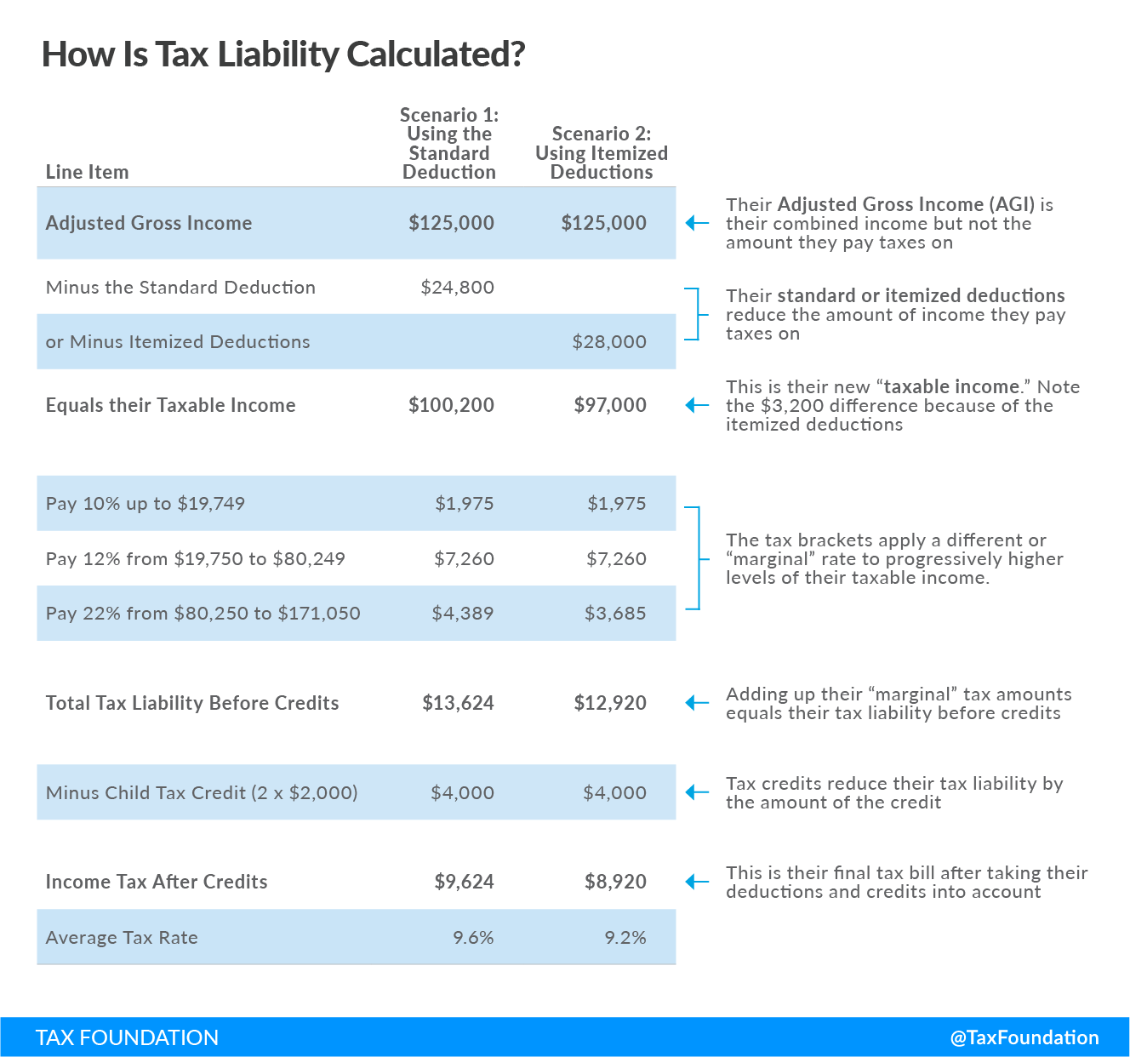
Marginal Tax Rate: The marginal tax rate is the amount of additional tax paid for every additional dollar earned as income. A 10 percent marginal tax rate means that 10 cents of every next dollar earned would be taken as tax.
There are statutory and effective marginal tax rates. Statutory marginal tax rates do not tell the entire story, whereas effective marginal tax rates account for layers of taxes (example: income tax and payroll tax) and relevant deductions and credits.
What it measures: impact on incentives to earn, save, invest, or spend

Key Points
- Marginal tax rates only apply to income above a certain threshold.
- The average tax rate for individuals is typically lower than the top marginal tax rate.
- Not all income is subject to taxation due to tax credits and deductions.
- A taxpayer’s tax liability is determined by their taxable income.
- The U.S. has a progressive federal income tax system.
- High income taxpayers typically pay a higher average tax rate and are subject to higher top marginal income tax rates as their income climbs.
- Effective marginal tax rates are important to calculate because they show how workers may be discouraged to work additional hours and earn higher incomes.
- Higher effective marginal tax rates disincentivize additional work at the margin, which translates into lower productivity and economic growth overall.

